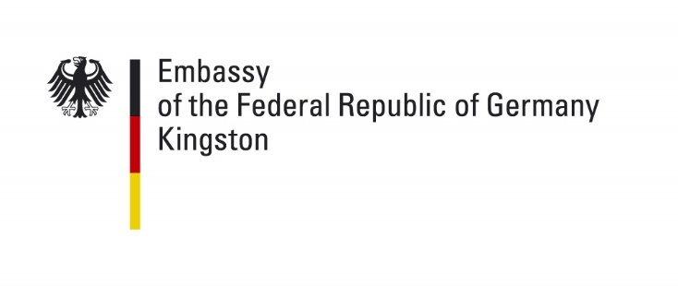 | July 2026

Applying for a German Passport

Applications for a German Passport must be submitted in person at the Embassy, after scheduling an appointment. Minors are also required to appear in person, accompanied by their by parents/legal guardian(s). If one of the parents/legal guardians cannot be present, his/her signed and certified consent to the passport application must also be submitted.

An appointment must be booked using the online appointment system on our website. To book your appointment, please click here. Please understand that appointments cannot be booked by telephone or by email.

The administrative district, for which the German Embassy in Kingston is responsible: Jamaica, Bahamas, Cayman Islands and Turks and Caicos Islands.

All applicants from the Bahamas, the Cayman Islands or from the Turks and Caicos Islands may email us a scan of their application with all supporting documents, so that we can check whether or not the application is in any way incomplete, before booking an appointment. In order to avoid unnecessary travel, an appointment should only be booked after you have received the go-ahead from us. It is also possible to hand in passport applications at the Honorary Consul’s office in the Bahamas and during the regular consular days on the Cayman Islands and the Turks and Caicos Islands.

Address: 10 Waterloo Road, Kingston 10
Telephone: +1 876 619 3132 (DIGICEL) oder
+1 876 631 7935 (FLOW)
Fax: +1 876 620 5457 (FLOW)
Email: info@kingston.diplo.de

Please bring to the appointment the fully completed application form and two recent biometric photographs. The application form as well as important information on the biometric photographs can be found here.

The following documents must also be submitted in original or as a certified copy:
- Your current German passport
- Birth Certificate
- The registration or de-registration from your current or last place of residence in Germany (in the case that you have ever lived in Germany)
- The residence permit or work permit for Jamaica (incl. Alien Registration Card), the Bahamas, the Cayman Islands or the Turks and Caicos Islands
- An extract from the Family Register (Family Book) or your Marriage Certificate (if you have ever been married)
- Certificate of Name Declaration (if applicable)
- Proof of Nationality or Certificate of Naturalization (if applicable)
- Certificate of Acquisition of a foreign nationality or a Travel Document or ID (Identity Card) issued to you by another state (if applicable)
- Certificate of Retention of German Citizenship issued by a German Citizenship Authority (if applicable)
- In the case that your passport has been lost or stolen, you must present a police report on the loss or theft.

In addition to the above, additional documents are required in the case of minors applying for a passport. These must also be presented in original or as a certified copy:
- Current passport or Identification Card of the parents/legal guardians
- An extract from the Family Register (Family Book) of the parents or the Marriage Certificate of the parents (if they were ever married to each other)
- Proof of relationship to the German parent, e.g. birth certificate, recognition of paternity, adoption certificate etc.
- Proof of Nationality or Certificate of Naturalization of the German parent (if applicable)
- Proof of sole custody by means of a Court Order or Divorce Decree of the parents, or by the Death Certificate of a deceased parent (if applicable)
- A Name Declaration must be done, for the first time application of a child born abroad, whose parents do not have an official family name (Ehename) according to German law and joint custody. Information on this may be found on the relevant pages of the German Embassy’s website.

Additional documents may be required in individual cases.

In addition to the passport application, other questions concerning citizenship or civil status matters may also need to be clarified and in that case, the documents will have an Apostille stamp before they are presented to the Embassy.

Jamaican documents are foreseen with an Apostille by the Jamaican Foreign Ministry (2 Port Royal Street, Kingston. Tel.: 001 876-926-4220 or 001 876-929-6733). Documents issued in the Cayman Islands or in the Turks and Caicos Islands require an Apostille from the respective Governor General’s Office.
All other official documents which have not been issued in Germany must either be legalized or have the Apostille stamp. To find out whether your document needs to be legalized or if it must have the Apostille stamp, please check the detailed information of the German Foreign Ministry here.

All fees must be paid in full upon application. Payment may be made either in US Dollars cash or by credit card (VISA or MasterCard) according to the exchange rate of the Embassy. For payments by credit card, the credit card holder must be present. Payments by credit card are calculated in Euro and no refund is possible once a credit card payment has already been made (e.g. after the denial of an application). Please note that additional processing fees may be charged by your bank for this transaction. Unfortunately, payment by cheque, by EC-card or with Euro cash is not possible.

Fees | with residence in  administrative  district and  de-registered from Germany | Without residence  in administrative  district or still  registered in  Germany
Passport for applicants from 24 years of age  (Validity: 10 years, 32 pages)  incl. Foreign surcharge | 106,00 EUR | 176,00 EUR
Passport for applicants under 24 years of age  (Validity: 6 years, 32 pages)  incl. Foreign surcharge | 73,50 EUR | 111,00 EUR
Passport with additional pages (a total of 48 pages) | plus  22,00 EUR | plus  22,00 EUR
Expedited service | plus 32,00 EUR | plus 32,00 EUR
Temporary Passport (Validity: 1 year)  Please note: Does not fall within the “US Visa Waiver Agreement”. A visa is needed for entry into the USA when travelling with a Temporary Passport. | 75,00 EUR | 101,00 EUR
Travel permit in lieu of a passport | 57,00 EUR | 57,00 EUR
Change of Place of Residence in passport | 0,00€ | Not possible

Please note that your passport application can only be processed when all required documents have been submitted and the necessary fees have been paid in full. The processing time for passports is approximately 8 to 11 weeks since they are produced in Germany. You may request to have your passport issued as an express service for a surcharge of 32.00 €. The process is shortened by approx. 8 working days but there would be no change, however, in the courier delivery times. In cases of emergency, you may also apply for a Temporary Passport, with a validity of up to 1 year.

If you hand in your application through the honorary consul in the Bahamas, a surcharge of 74.51 € applies plus further costs for incurred expenses (courier costs, etc.).

Do you wish to change your surname after marriage or after a divorce? In this case, please contact the Embassy beforehand to clarify whether or not you will also need to do a Name Declaration /or have your Divorce recognized in Germany. If so, you may need to provide additional information and documentation and the processing time may be extended.

Your passport may be collected in person during our opening hours from Monday to Friday between 8:30am and 11:30am. Please bring your previous passport with you when you come in to collect. This will be cancelled and returned to you (e.g. in case you have valid visas or permits entered there) together with your new passport. If you wish to have your passport collected by someone on your behalf, please ensure that the person collecting has a signed authorization note from you. Alternatively, you may have your passport delivered to your address by a courier service, at your own cost. Please note that in these cases, the Embassy would still need to have your old passport, so that it can be cancelled, before we can hand over the new one.

Should you have any queries, please feel free to contact the Embassy.

